**DFT_MedAptus_GECentricity Business Reqs**

**Version1.1**

**Prepared By: Art Schwartz**

**Date: 1/3/2017**

Document Control 3

Resources 3

Project Distribution List 3

Document Version Control 3

1. Introduction 4

1.1 Purpose 4

1.2 Project Scope 4

1.3 Terminology Standards 4

1.3.1 Acronyms 4

1.3.2 Glossary 4

1.4 Document References 4

*2.* Diagram 5

3. Requirements 6

3.1 Functional Requirements 6

3.2 Non-Functional Requirements 6

3.3 Messaging Protocols 7

3.3.1 Inbound to the BayCare Cloverleaf 7

3.3.2 Outbound to the BayCare Cloverleaf 7

3.3.3 Inbound to the Vendor 7

3.3.4 Outbound to the Vendor 7

4.1 Messaging Format 7

4.1.1 Segments 7

4.1*.*2 Messaging Event Types 8

4.1*.*3 Cloverleaf Configuration Files 8

4.1.4 Cloverleaf Site Location 8

4.2 Data Transformation Requirements 9

4.3 Sample Message 11

5. Testing 12

5.1. Unit Testing Scenarios 12

5.2 Integrated Testing Scenarios 12

5.3 Testing Approvals 12

5.4 Piloting 13

5.5 Approvals 13

6. Deployment / Implementation Model 14

6.1 Alerts 14

Appendix A: Risks and Concerns 14

Appendix B: Issues List 14

# **Document Control**

## Resources

|  |  |  |
| --- | --- | --- |
| **Name** | **Role** | **Email** |
| Schwartz, Art | IS Integration Analyst, Sr | Art.schwartz@baycare.org |
|  |  |  |
|  |  |  |
|  |  |  |
|  |  |  |
|  |  |  |
|  |  |  |
|  |  |  |

## Project Distribution List

## Document Version Control

|  |  |  |  |
| --- | --- | --- | --- |
| **Version** | **Date** | **Modifier** | **Description** |
| V1.0 | 9/26/2016 | Lois Whitley | Originally Created |
| V1.1 | 1/3/2017 | Art Schwartz | Cloverleaf information added |
|  |  |  |  |
|  |  |  |  |

# 1. Introduction

## 1.1 Purpose

This document outlines the DFT charge interface outbound from MedAptus Pro Charge Capture to GE Centricity Business (GECB). MedAptus gives you clean charges from which to do billing. Soarian sends a real time HL7 ADT feed with visit and demographic data to MedAptus. Cerner PowerChart Ambulatory also sends the EMR rounding list interface (care team list) to MedAptus. Professional Charge Data is then sent to GECB via a nightly HL7 DFT export.

## 1.2 Project Scope

The scope of this project is to implement the outbound professional charge interface (DFT) from MedAptus to GECB in the form of an HL7 DFT nightly export.

## 1.3 Terminology Standards

### 1.3.1 Acronyms

DFT – Detail Financial Transaction Message

GECB – GE Centricity Business

### 1.3.2 Glossary

List the terms that require definition with respect to Cloverleaf and the product whose requirements are defined in this document. The definitions are specific to this document and may not be identical to the definitions of these terms in common use.

## 1.4 Document References

1. MedAptus Charge Outbound Standard – 2015-01

2. MedAptus Data Flow

# *2.* Diagram

Provide a solution diagram that depicts the integration of components specified in this IDBB. This diagram must include the data flow for the interfaces (source and target).

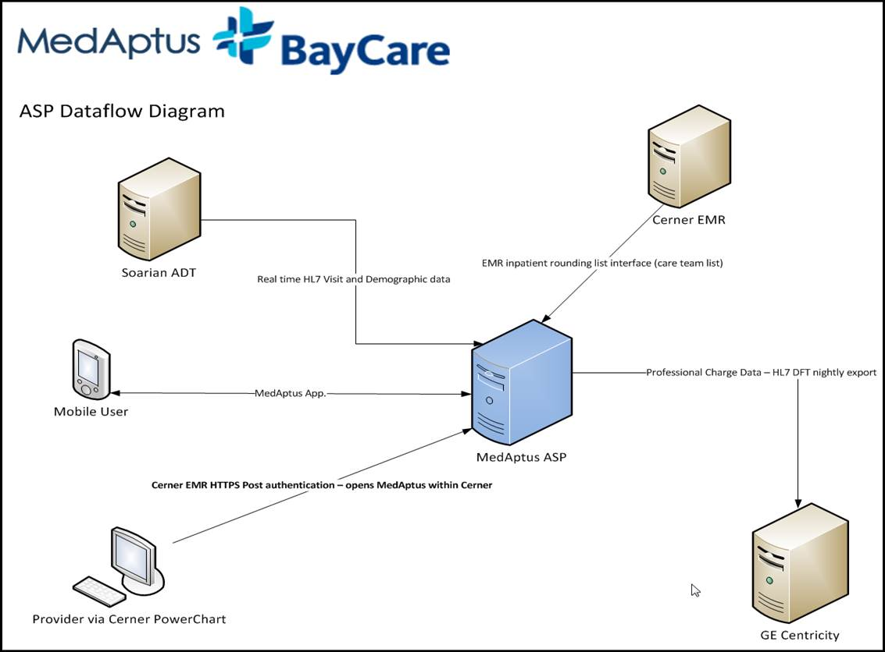

# 3. Requirements

## 3.1 Functional Requirements

Provide detail for the below functional requirements. The message transformation requirements for the components defined in this specification should be specified in section 4.2 of this document.

|  |  |  |
| --- | --- | --- |
| **Cloverleaf** |  |  |
| **Number** | **Requirement Name** | **Requirement Description** |
| FR.20XX.1.0 | Click here to enter text. | Click here to enter text. |

## 3.2 Non-Functional Requirements

Provide concise detail for the below non-functional requirements. The below requirements must be evaluated for every project.

|  |  |  |
| --- | --- | --- |
| **Cloverleaf** |  |  |
| **Number** | **Requirement Name** | **Requirement Description** |
| NFR.20XX.1.0 | Click here to enter text. | Click here to enter text. |

## 3.3 Messaging Protocols

Below are listed the details for the messaging protocols that will be leveraged for this integration. Please see the reference document located on the Integration SharePoint server: <insert link to document here>

### 3.3.1 Inbound to the BayCare Cloverleaf

* Prod: inbound port on CL is 23058, IP is 10.5.250.201
* Test: inbound port on CL is 23058, IP is 10.5.250.203

### 3.3.2 Outbound to the BayCare Cloverleaf

* Prod: out bound IP, port  on GE is 198.181.235.5,  23059
* Test:  out bound port on GE is 198.181.235.5,  23058

### 3.3.3 Inbound to the Vendor

* Click here to enter text.

### 3.3.4 Outbound to the Vendor

* Click here to enter text.

4. HL7 Messaging

## 4.1 Messaging Format

### 4.1.1 Segments

The segments utilized for this interface are:

MSH

EVN

PID

PV1

FT1

ZFT

ZHI

*Message Construction Notes:*

*[Square Brackets] – Optional*

*{Curly Brackets} – Repeatable*

*MSH – Message Header*

*EVN – Event segment*

*PID – Patient ID segment*

*PV1 – Patient Visit segment*

*FT1 – Financial Transaction segment*

*ZFT – Insurance segment*

*ZHI -*

*[{ – Start of optional, repeatable group*

*}] – End of optional, repeatable group*

### 4.1*.*2 Messaging Event Types

Below are the messages types necessary for this integration

|  |  |
| --- | --- |
| **Event Type** | **Description** |
| DFT^P03 | Post Detailed Financial Transaction(s) |

### 4.1*.*3 Cloverleaf Configuration Files

For each HL7 interface specified in Section 2 of this document, identify the Cloverleaf Configuration Files: Variants, TCL Scripts, Xlates, etc.

This is a raw route and no translate or procs are used.

### 4.1.4 Cloverleaf Site Location

Cloverleaf site locations bmg_1_p.

## 4.2 Data Transformation Requirements

| **Field Description** | **HL7 Field Loc.** | **Required Y/N** | **Data Type** | **Length** | **Notes** |
| --- | --- | --- | --- | --- | --- |
| Message Header Segment | MSH |  |  |  |  |
| Sending Application | MSH.3 |  |  |  | MDAP |
| Receiving Application | MSH.5 |  |  |  |  |
| Date/Time of Message | MSH.7 |  |  |  | YYYYMMDDHHmm |
| Message Type | MSH.9 |  |  |  | DFT^P03 |
| Message Control ID | MSH.10 |  |  |  | Encounter SQL GUID |
| Event Type | EVN |  |  |  |  |
| Event Type Code | EVN.1 |  |  |  | P03 |
| Recorded Date/Time | EVN.2 |  |  |  | YYYYMMDDHHmm |
| Patient Identification | PID |  |  |  | Will only be included if there is Primary Care Provider information associated with the episode |
| Patient Identifier List | PID.3 |  |  |  |  |
| Patient Name | PID.5 |  |  |  | Last Name^First Name^ |
| Patient Visit | PV1 |  |  |  | Required by MedAptus; contains Attending Provider, which is a required field. HL7 message data will not be loaded into MedAptus if this segment is not sent |
| Attending Doctor | PV1.7 |  |  |  | Attending Doctor Outbound ID^Attending Last Name^Attending First Name; this is the scheduled doctor for outpatient; attending for inpatients. The ID value is the constant taken from the Provider Table for the Attending Provider associated with the encounter |
| Referring Doctor | PV1.8 |  |  |  | Referring Doctor Code^Referring Doctor Full Name |
| Visit Number | PV1.19 |  |  |  | Visit Number (typically Account Number value from ADT if charge is for a hospital based visit) |
| Admit Date/Time | PV1.44 |  |  |  | Visit Date |
| Alternate Visit ID | PV1.50 |  |  |  |  |
| Financial Transaction | FT1 |  |  |  |  |
| Transaction Date | FT1.4 |  |  |  | Date of Encounter |
| Transaction Type | FT1.6 |  |  |  | CG |
| Transaction Quantity | FT1.10 |  |  |  | Units; Integer number with no leading zeroes |
| Insurance Plan ID | FT1.14 |  |  |  | Plan Code, Plan Name; taken from the primary insurance associated with the encounter |
| Assigned Patient Location | FT1.16 |  |  |  | Location Outbound ID; value is the constant taken from the Location Table for the Location associated with the encounter |
| Diagnosis Code | FT1.19 |  |  |  | ICDCode1 thru ICDCode12 separated by a tilde ‘~’ |
| Performed by Code | FT1.20 |  |  |  | Encounter Doctor Outbound ID  Encounter Doctor First and Last Name; the ID is the constant taken from the Provider Table for the Provider associated with the encounter |
| Ordered by Code | FT1.21 |  |  |  |  |
| Procedure Code | FT1.25 |  |  |  | CPT4 Procedure Code |

## 4.3 Sample Message

Inbound and Outbound are the same because it’s a raw route with no changes made to the message.

Inbound

MSH|^~\&|MDAP||IDX_TES_CHG||20160921170339||DFT^P03|2016092100001|P^T|2.4|

EVN|P03|20160921170339||

PID|1||300146795||TEST^MEDAPTUSONE^||

PV1|1|||||||14723^BAKER MD^MARK B|||||||||||6000012288|||||||||||||||||||||||||20160314| |||||6000012288|

FT1|1|||20160921||CG||||1||||100||328|||G71.0~B26.3~C21.1~D18.00~E27.49~F13.120~G11.9~H21.1X1|194^Baird^Christopher|^^||||99232|

ZFT||4|||||19700101||

ZHI||XX|||||

Outbound

MSH|^~\&|MDAP||IDX_TES_CHG||20160921170339||DFT^P03|2016092100001|P^T|2.4|

EVN|P03|20160921170339||

PID|1||300146795||TEST^MEDAPTUSONE^||

PV1|1|||||||14723^BAKER MD^MARK B|||||||||||6000012288|||||||||||||||||||||||||20160314| |||||6000012288|

FT1|1|||20160921||CG||||1||||100||328|||G71.0~B26.3~C21.1~D18.00~E27.49~F13.120~G11.9~H21.1X1|194^Baird^Christopher|^^||||99232|

ZFT||4|||||19700101||

ZHI||XX|||||

# **5. Testing**

## 5.1. Unit Testing Scenarios

|  |  |
| --- | --- |
| **Scenario** | **Expected Result** |
|  |  |
|  |  |
|  |  |
|  |  |
|  |  |

## 5.2 Integrated Testing Scenarios

|  |  |
| --- | --- |
| **Scenario** | **Expected Result** |
|  |  |
|  |  |
|  |  |
|  |  |
|  |  |
|  |  |

## 5.3 Testing Approvals

|  |  |  |  |
| --- | --- | --- | --- |
| **Testing Phase** | **Date** | **Department** | **Team Member** |
| PH1.UNIT |  |  |  |
| PH1.INTEGRATED |  |  |  |

### 

## 5.4 Piloting

List the facilities and associated networks in scope for pilot testing.

## 5.5 Approvals

|  |  |  |  |
| --- | --- | --- | --- |
| **Testing Phase** | **Date** | **Department** | **Team Member** |
| PH1.0 |  |  |  |
|  |  |  |  |
|  |  |  |  |

# 6. Deployment / Implementation Model

Provide the detail as to how to deploy the solution defined in the IDBB from both the BAYCARE and vendor perspective.

## 6.1 Alerts

Are you going to need alerting on this connection?

|  |  |
| --- | --- |
| Yes |  |
| No |  |

If the answer is yes, please complete the table below:

|  |  |  |  |
| --- | --- | --- | --- |
| **Site Name** | **Hours of Support** | **Distribution Group** | **Comments** |
|  |  |  |  |
|  |  |  |  |

# Appendix A: Risks and Concerns

|  |  |  |  |  |  |  |  |  |
| --- | --- | --- | --- | --- | --- | --- | --- | --- |
| **Project Name** |  |  | | |  |  |  |  |
| **Number** | **Risk / Concern** | **Comment** | **Mitigation** | | |  |  |  |
| RC.2013.1.0 |  |  | |  | |  |  |  |

# Appendix B: Issues List

This is a dynamic list of the open issues related to the IDBB that remain to be solved, including but not limited to TBDs, pending decisions, information needed, conflict awaiting resolution, and the like.

|  |  |  |  |  |  |  |  |  |
| --- | --- | --- | --- | --- | --- | --- | --- | --- |
| **Project Name** |  |  | | |  |  |  |  |
| **Number** | **Issue** | **Comment** | **Fix** | | |  |  |  |
| I.2013.1.0 |  |  | |  | |  |  |  |

* End of document